The Ansen Hotel

GUI User Manual

**Table of Contents**

**Staff Login**

*Creating a Reservation* 2

*Searching a Reservation* 3

*Editing/Deleting Guest Information* 3-4

**Guest**

*Searching a Reservation* 4-5

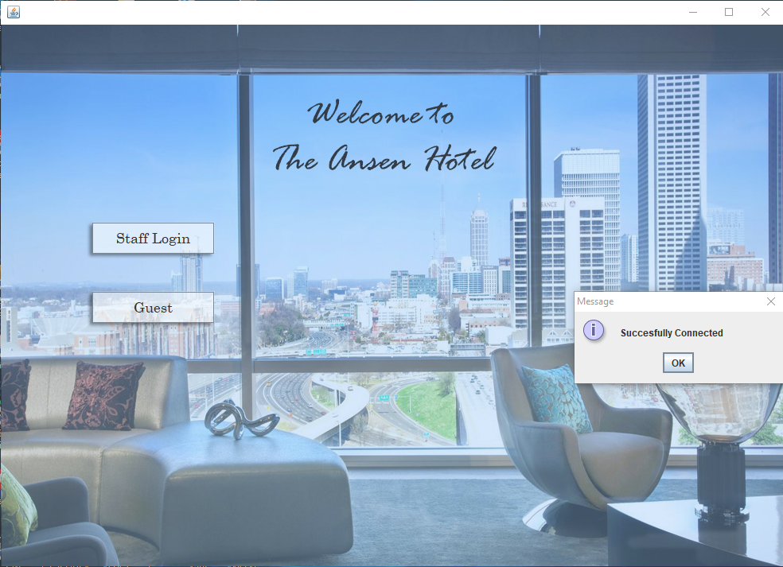

1. **Staff Login**

*Creating a Reservation*

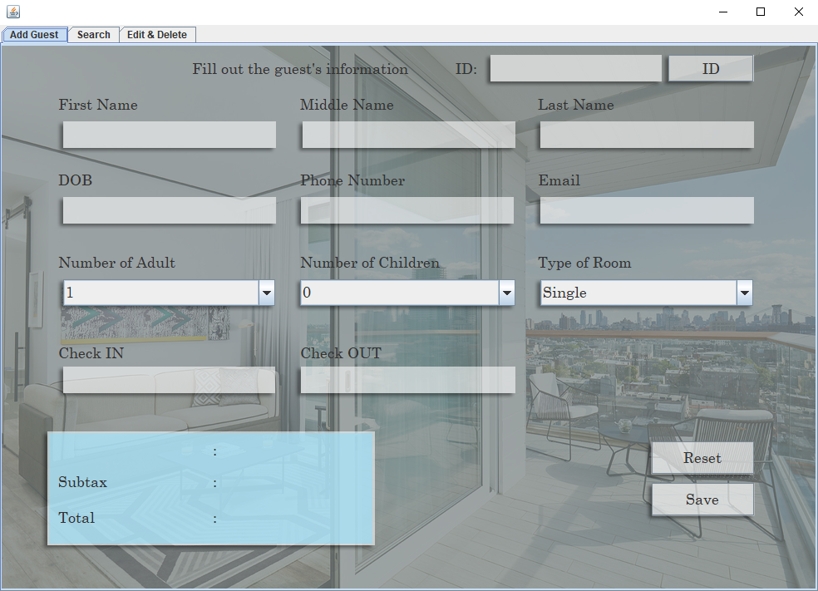The Ansen Hotel interface allows staff members to create, search, edit, and delete reservations. When they run the GUI, they are presented with a login screen to access the hotel’s database. After logging into the system, they can select the “Add Guest” panel and input the guest’s first name, middle name, last name, date of birth, phone number, email, and check-in and check-out dates. They have to enter the number of adults and children under the reservation, and the type of room the guest would like to reserve (Single, Double, Suite). Depending on the type of room selected, the total cost of the stay will be displayed. After filling out all of the fields, the staff member must click on the “ID” button to generate a confirmation number for each reservation. This ID will distinguish each reservation and serve as a key for searching them.

*Searching a Reservation*

To search a reservation, the staff member has to select the “Search” panel and input the ID generated when the reservation was created. If the ID is correct, the GUI will display the guest’s data. If the ID is invalid, then the information will not appear.

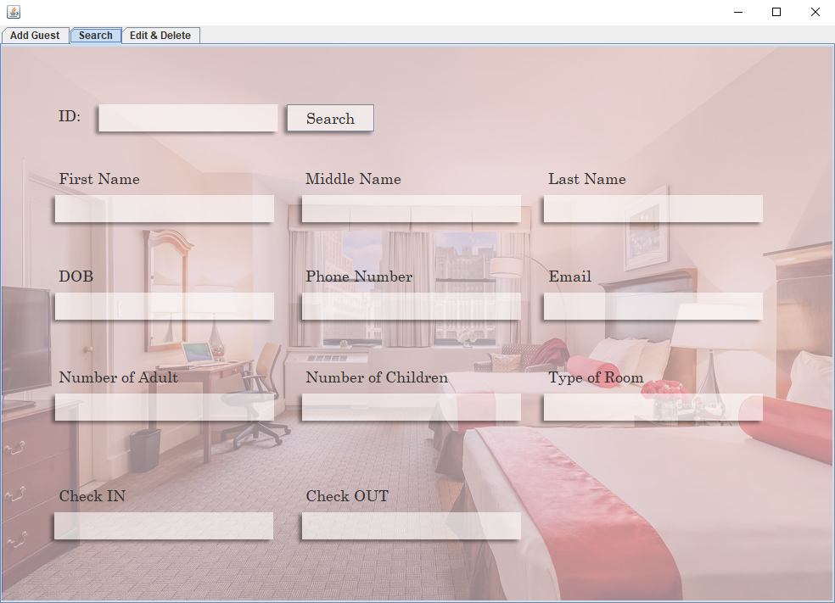

*Editing/Deleting Guest Information*

After logging into the hotel’s database system, the staff member has to select the “Edit & Delete” panel to edit or delete a guest’s reservation. They will have to enter the ID that was previously generated when the reservation was created. If the ID is correct, the guest’s information will appear in the fields. Once the data is displayed, the staff member can edit the information by modifying the information in the textboxes and selecting the “Update” option. They can also delete the reservation by pressing the “Delete” button.

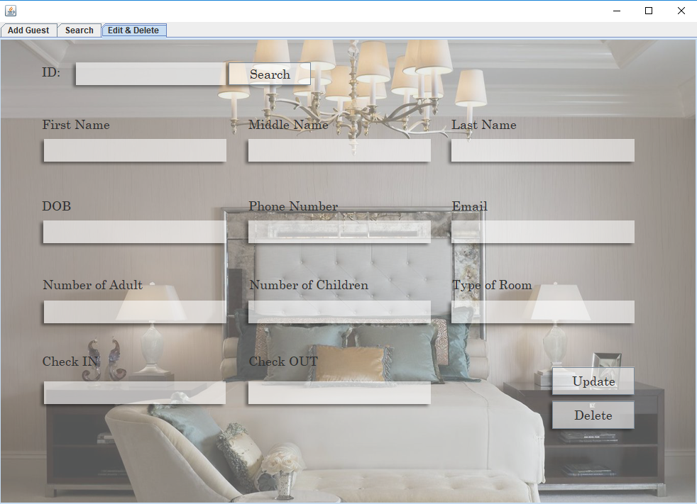

1. **Guest**

*Searching a Reservation*

Since this interface functions for both the hotel staff and guests, it enables guests to search their reservation and confirm whether the information in the database is correct. Upon launching the application, the guest has to select the “Guest” option and will then be directed to the “Search” panel. Here, they have to input the ID that was generated when their reservation was created. If the ID is correct, the GUI will display the guest’s data. If the ID is invalid, then the information will not appear.